**Davy McKee-------------==c::....·**·_.:(v:....:..Ui f....:_K-_- _, _· _

**DAVY MCKEE PLASMA** TECHNOLOGY FOR **METALS** RECOVERY BY SMELTING AND

**MELTING** PROC£SSES

Prepared by: David Naden

August 1988

088/945

J

J

l

D

□

|  |
| --- |
| J  l |
| J J |
| 7  J |
| J  l |
| l  J |
| J  0 |

�

D

0

l

**Davy McKee --.**

DAVY t«:ICEE PLASMA TECHNOLOGY FOR FERRO-ALLOYS, IRON AND STEEL AND METALS RECOVERY FR<l4 STEEL PLANT BY-PRODUCTS

CONTENTS Page Number

1. INTRODUCTION 1
2. DISCUSSION OF PLAMSA TECHNOLOGY 3
   1. Applications of Plasma Technology to Metallurgical 3

Processes

* 1. Selection of Plasma Furnace Design 3
     1. Discussion of Plasma Furnace Design 3
     2. Application of DC Transfered Plasma Arc 4

1. DAVY MCKEE PLASMA FURNACE TECHNOLOGY (HI-PLAS) 7
   1. Davy McKee Hi-plas furnace Design Principles 7
   2. Description of the Davy McKee Plasma Furnace 11

Pilot Plant

* 1. Status of the Davy McKee Development of the 13

Plasma Furnace

* 1. The 5 MW Co1111lercial Plant 14

1. HI-PLAS MELTING OF METALS AND METAL FINES 17
   1. Introduction, Advantages of Plasma Melting 17
   2. Metal Fines Melting 17
      1. Introduction 17
      2. Ferro Manganese Metal Fines Melting 18
   3. Scrap Melting 18
      1. Incentive for New Scrap Melting Technology 18
      2. High Power Plasma Furnace Cost Advantages 20
2. INTEGRATED ORE PRETREATMENT OF PLASMA SMELTING PROCESS 22
   1. Process Concept 22
   2. Status of the Integrated Process Technology 25

D88/945

J

###### J J J J J J 0

�

�

###### J

0

# u

8

0

# u

Q

D J J

l

**DavyMcKee-------------------**

1. METALS RECOVERY FROM ELECTRIC ARC FURNACE (EAF) DUST 26
   1. Introduction 26
   2. Sunmary of Davy Mckee Hi-plas Process 26
2. METALS RECOVERY FROM FERRO-ALLOY SLAGS 30

APPENDIX 1: HI-PLAS, DAVY MCKEE HIGH INTENSITY PLASMA ARC SYSTEMS

APPENDIX 2: THEORETICAL **BASIS** OF DAVY MCKEE HI-PLAS FURNACE TECHNOLOGY

APPENDIX 3: DAVY MCKEE PUBLICATIONS IN

PLASMA TECHNOLOGY

APPENDIX 4: 11A 5 MW PLASMA ARC FURNACE FOR PRODUCTION OF FERRO-ALLOYS11 PAPER PRESENTED AT THE AUSTRALIAN INSTITUTE OF ENERGY, HIGH ENERGY TECHNOLOGY SEMINAR IN MELBOURNE. AUSTRALIA, JULY 1988

088/945

J

##### J

l

)

]

J J J J

7

J

l l

7

*J*

7

_I,

l

l

l

**Davy McKee --.**

**DAVY r«:KEE PLASMA** TECHNOLOGY FOR FERRO-ALLOYS, **IRON AND** STEEL **AND METAL**

**RECOVERY FROM STEEL PLANT BY-PRODUCTS**

1. **INTRODUCTION**

Davy Mckee have extensive experience in de plasma arc technology based on knowhow gained in activities in the Davy McKee plasma furnace pilot plant carried out since 1982. The Davy **McKee** Hi­ plas melting and smelting furnace is a unique design of plasma furnace using long transferred arcs in a high throughput cyclone reactor system. The full potential of long arcs is used and a high level of electrical efficiency is achieved.

Plasma arc technology is now well established on the industrial scale in processes ranging from Ti02 production, acetylene from

oil, scrap melting (30 **MW** furnace), ferrochrome production from

ore (20 MW). In July 1988 the first Australian industrial plasma furnace operating on a metallurgical process started up using Davy McKee Hi-plas technology in a 5 MW furnace. In addition, **a 1 MW** Hi-plas furnace is also operating in a development facility in Australia and a 1 MW pilot plant will be in operation in a steel plant in Korea in 1989.

One of the principal advantages of the Hi-plas furnace is the ability to produce metals by the direct smelting of ore fines using coal and the direct melting of metal fines without prior agglomeration. Engineering design and metallurgical pilot plant studies have been carried out to evaluate the application of Hi­ plas technology to metals production and recovery in a wide range of processes eg:-

1. Iron and ferroalloys production from ore fines, including bauxite smelting.
2. The recovery of metals (eg Fe, Cr, Ni, V, Mn, Mo etc) from stainless steel plant dust arisings is an economically

D88/945 l

u

0

0

J J J J 0 J J J J J

### n

l J J J 7

7

l

**Davy McKee --.**

attractive process which is a preferred alternative to disposal as land-fill.

c} The production of high value alloys from metal containing slags.

d} High value metal production from metal fines melting and processing.

At the same time parallel studies have been carried out on fluid­ bed ore reduction using plasma furnace off gas, which has led to processes for integrated fluid-bed ore reduction and plasma smelting for metals production from ore fines.

In the field of metals melting the Davy McKee Hi-plas melting furnace technology is applicable to a wide range of melting processes including conventional metal scrap melting, metal fines melting (as noted above) and processes in which a closed furnace and controlled environment are either desirable or essential. Th company has also begun the development of a new engineering approach to plasma torch design which it is anticipated will result in a much higher power torch than those conventionally operated.

This document summarises aspects of Davy McKee developments, and activities in plasma technology and in the development of process routes involving Hi-plas and other Davy McKee technologies.

088/945 2

J

###### J

J

J

]

]

]

###### J

]

l J J

□

]

J

l

l

]

###### J

l

**Davy McKee --.**

1. **DISCUSSION OF PLASMA TECHNOLOGY**
   1. **Application of Plasaa Technology to Metallurgical Processes**

**Wide** ranging studies by Davy McKee have shown that plasma technology offers economically attractive metallurgical processes with considerable potential. The principle metallurgical uses of plasma identified are:-

1. Metal production from ore,
   1. **as a** heat source in the carbothennic reduction of ores to produce iron and ferro alloys using coal directly **as a** reductant,
   2. to produce reducing gas for DRl processes.
2. Melting processes such as,
   1. scrap melting to produce special steels, and
   2. metal fines remelting eg ferro-manganese.
3. Recovery of valuable metals from steel plant dust arisings, especially arc furnace dusts, and from slags.
   1. **Selection of Plasma Furnace Design**
      1. Discussion of Plasma furnace Design

Plasma reactors developed for application to the metals industry may be characterised as

* + - 1. Short arc gas heating reactors which may be operated on either a.c. or d.c. This type of plasma generator is remote from the melting or smelting section of the furnace and heat

088/945 3

J

###### J J J 7 J J J

]

l

J

**7**

**J**



**...J**

7

J

7

n

**Davy McKee --..**

is transferred from the generator to the reactor by a hot gas flow. The reactor must then be designed so that the required reactions occur in the hot gas or in a zone heated by the gas.

* + - 1. In flight reactors in which the reactants pass through a plasma zone. The reactant residence time is very short and hence reactions are difficult to take to completion. In addition the system is very inefficient in tenns of energy use. The high temperature achieved and short residence time is however used in such reactions as the thennal dissociation of zircon sand where the electrical inefficiency is not important as the product has high value.
      2. The d.c. transferred arc reactor in which a gas stablished arc is struck between a cathode and an anode which is usually the reactant bath. This type of reactor is used in steel scrap melting processes and in ferro-alloys production in South Africa. As up to 90% of the heat in a long transferred arc can be in the fonn of radiant heat it is essential to design d.c. transferred arc reactors to use the radiant heat, in the interests of both efficiency of energy utilisation and to prevent damage to furnace roof and walls. The Davy McKee developed furnace, which is based on a proprietary concept is of this type and is described more fully in the following sections. Davy McKee have a world-wide licence to develop and market this design of furnace.
    1. Application of DC Transferred Plasma Arc

A de transferred plasma arc is a gas stabilised electric arc between a cathode and an anode in which the gas becomes ionised and is transformed into a plasma. Extended arcs of over 1 metre in length are possible with temperatures as high as 20,ooo•c. The plasma arc is a precise source of energy which is available both

as radiated heat from the arc and heat transferred to the anode. D88/945 4

**J**

**J**

**l** l l J J **J J**

l

7

I

*J*

**l**

J

J

#### 7

**l** J **J** 7

l

**l**

**Davy McKee ,**

The proportion of heat available as radiated heat increases as the arc length increases and in long arcs can be up to 90% of the energy of the arc (see Appendix 2).

The major potential uses and advantages of a direct current transferred arc plasma furnace are as follows :

* + - 1. Ore Smelting and Metal Fines Melting Processes,
         1. particulate feeds may be used directly without prior agglomeration processes,

ii} coal may be used directly **as a** reductant thus eliminating the need for coke,

1. high throughputs of particulate feeds may be achieved and this leads to compact low cost furnace,
2. the plasma arc is a source of energy which does not rely on in situ combustion of fossil fuels, both product contamination by combustion products and gas handling in smelting processes are therefore greatly reduced.
   * + 1. Ladle heating and slag heating in refining processes and metals recovery from slags.
       2. Melting of Scrap, ORI Product and Special Steels,
          1. use of light weight non-consumable electrodes,
          2. stable arc largely eliminates voltage disturbance and the need for flicker control equipment,
          3. use of high voltage, low current power supply enabling lower duty cables, busbars, etc to be used,

D88/945 5

J

###### J 0

0

###### J J J J J J J J

]

J 0 J

J

7

0

0

J

###### J

**Davy McKee--------' --.**

* + - * 1. lower environmental impact of noise, dust and waste gases,
        2. elimination of carbon electrode leads to higher purity product.

D88/945 6

J

###### J J

]

•

·1

J

]

J J J J J

-1

J

]

l 7 J 1

�

�

**Davy McKee --.**

1. DAVY **MCKEE PLASMA** FURNACE TECHNOLOGY (HI-PL.AS)
   1. Davy McKee Hi-plas Furnace Design Principles

Hi-plas is the generic name for Davy McKee plasma systems {see Appendix l}.

An extensive study of the properties of direct current (de) transferred plasma arcs has established that a substantial proportion of the energy in long plasma arcs is available as radiant and convected heat along the length of the arc.

Measurements carried out by Davy McKee in the Davy McKee plasma furnace pilot plant have shown that as the arc length increases the energy in the arc increases; a 50 cm long arc can radiate over 50% of the energy to the furnace while the radiation from a lm long arc can be 90% of the total arc energy available. If not used in the furnace reactions the radiated energy will result in damage to the furnace walls and roof. The successful operation of a de transferred arc plasma furnace therefore requires a new approach to furnace design and operation.

The Davy McKee Hi-plas smelting furnace is a unique design based on the plasma furnace design principles developed by Gauvin and Kubanek (US Patent 4,446,823) and on extensive pilot plant investigation by Davy McKee in the companies technical development facilities at Stockton-on-Tees, England. The Hi-plas furnace design principles are su111Tiarised in Figure 3.1. An argon stabilised de transferred arc (i) is struck between the non­ consumable water cooled cathode gun (ii) and the molten pool of reactants (iv) in the furnace hearth in cont ct with the anode in the bottom of the furnace (vi). The unique feature of the furnace is the water cooled reaction sleeve or cyclone reactor (iii) which surrounds a substantial length of the arc column (i). Reactants are injected tangentially into the sleeve (iii) **at a** number of points (v), above the plasma gun tip and with a sufficiently high velocity to form a unifonn covering to the inner wall of the

088/945 7

J

J J 1 J J

]

]

]

]

##### J

Q

�

1

]

l J J

7

,.I

l

7

**Davy McKee --.**

reaction sleeve. Radiant and convected heat from the arc melts the reactants to fonn a falling film of molten material flowing down the inner wall of the sleeve. The molten material then drops into the furnace hearth region where the reaction is completed in the molten bath heated by the impingement of the plasma arc. The continuous introduction of the reactants around the point of impingement of the arc prevents local overheating at the arc root. Full advantage is therefore taken in this design of all the heat in the plasma column which is used in the melting and smelting reactions. Arc radiation and heat transfer by convection to the furnace walls and roof is minimised.

The operation of the plasma torch from a location which is remote from the hot furnace reactants ensures that the torch is not exposed to damage by splashing and hot fume. The resulting long arc is stabilised by the vortex action of the injection and reaction gases in the sleeve reactor. Arc instability caused by the turbulent gases in the smelting furnace is therefore avoided.

The furnace is designed so that the plasma torch can be readily raised and lowered in the vertical axis. On start-up the torch will be lowered to strike using a very short arc then raised into the operating position within the sleeve when feed is introduced. During operation the arc length may be Im to 1.5m above the surface of the material in the furnace hearth. As arc voltage is fixed for a particular arc length and furnace operating conditions, varying the arc length also allows adjustments to be made to arc voltage during operation. Raising the plasma torch- during operation compensates for the increase in bath height due to the metal and slag accumulation in the hearth. A constant arc length and therefore constant voltage is maintained during the smelting operation.

The arc power is controlled by varying the current at constant arc voltage. Using pure argon the voltage drop in the arc is approximately 2 v/cm. When feed is introduced to the sleeve

D88/945 8

J

##### J

]

*]*

##### J

7

l

J

|  |
| --- |
| J  .l l  7*_,J* |
| J  l  7  1 |
| 7  j |
|  |
| J  J  l  l  *_)* |

l

**Davy McKee --.**

reactor in the smelting process, however, dust and product gases

{CO, CO2, H2 and H2o etc) are entrained into the plasma arc and the voltage drop can increase to 10 v/cm. The arc power is

therefore increased by a similar ratio, as power radiated is proportional to voltage drop in the arc. The power is therefore i111nediately available to the reactants as soon as they are introduced to the sleeve reactor.

The furnace is shown in Figure 3.1. with a submerged taphole. The furnace can however also be designed to be poured by tilting.

The features of the Davy McKee furnace design are su111narised as follows:-

* + 1. Accepts fine feeds, the need for agglomeration is therefore eliminated.
    2. Rapid reaction in the sleeve reactor leads to a compact furnace design.
    3. High efficiency of electric power useage due to the use of arc radiant heat in the sleeve reactor.
    4. Long arc stability is achieved by the vortex action of the gas flows in the sleeve reactor.
    5. The plasma torch is remote from the hot furnace atmosphere and torch damage from this cause is therefore eliminated.
    6. Damage to furnace walls and roof by radiation from the transferred plasma arc is minimised by the use of the sleeve reactor.
    7. Flexibility in the selection of feeds, reductants and products.

D88/945 9

J

;]

###### J

J

l

7

l

J



J

]

J

7

7

J

7

7

J'

###### J

J

7

7

l

**Davy McKee ,**

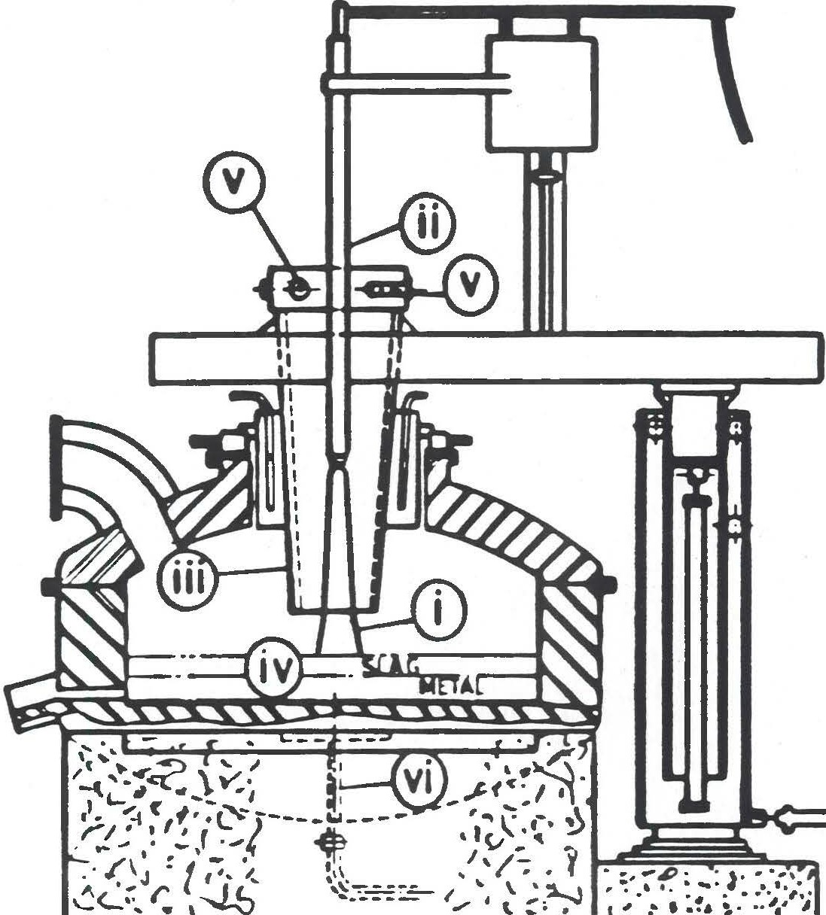

Figure 3.1 Davy McKee Plasaa Furnace Design Principles

D88/945 10

J

##### J

l

]

-]

]

l

##### J

l

###### J

l

]

1

l

7

\

7

l

*j*

##### J

7

l

l

**Davy McKee --.**

* 1. Description of the Davy **McKee Plasaa** Furnace Pilot Plant

A plasma furnace pilot plant based on the principles described in Section 3.1 has been designed and installed by Davy McKee in the company1s Research and Development facility in Stockton-on-Tees, England. A photograph of the pilot plant is shown in Figure 3.2.

The pilot plant comprises the following equipment:-

* + 1. The refractory lined tilting furnace body with a nominal capacity of 250 kg together with return path (anode) electrical contact system, and contact connections.
    2. The removable furnace lid assembly together with refractory lining, incorporating the reaction sleeve and feed entry system, and the plasma gun (cathode) entry port.
    3. The plasma gun assembly together with: gas feeding, water cooling systems, plasma gun raising and lowering system located on the furnace lid assembly, plasma gun height measuring system and electrical connections.
    4. Solid feed weigh hopper located on the platfonn adjacent to the plasma furnace.
    5. Solid feed injection system and feed control system located at the base o.f the feed hopper.
    6. High frequency arc initiation circuit located behind the feed hopper on the platfonn adjacent to the furnace.
    7. Gas scrubbing and venting system together with temperature sensing thennocouples.

D88/945 11

J

J

l l J

l J J J

.]

##### J

Q

###### J

]

J J J J D J 7

**Davy McKee --.**

* + 1. Electrical rectification, transfonner, supply and circuit breaking systems to supply a power of up to 1 MW in the range 500 to 2000 amps.
    2. All control and trip-out mechanisms associated with (a) to

(h) above.

* + 1. Temperature and water flow and gas flow recording and control systems.
    2. Equipment for on-line product gas analysis (not shown in the photograph in Figure 3.2).

In addition to the plasma furnace pilot plant equipment detailed above, ancillary equipment comprises:-

1. Ovens for ore drying.
2. Feed crushing and milling equipment ie, jaw crushers and ball mills.
3. Feed mixing.and blending equipment.
4. Sieves for ore grading.
5. The full support facilities of a modern laboratory in which both solid and gas analysis can be carried out.
6. Access to local contract laboratories for analysis of the whole range of minerals and elements to be encountered in the present programne.

**088/945 12**

J

l

]

]

l

1

]

##### J

]

•

7

J

7

**Davy McKee ,**

* 1. Status of the Davy McKee Developaent of the Plasaa Furnace
     1. The de transferred arc plasma gun design has been operated over long periods at a current rating equivalent to 1 MW in the operation of an extended plasma arc.
     2. The present design of plasma gun, reaction sleeve and furnace has been operated up to a 350 kW in:-
        1. the continuous smelting of iron ore to produce hot metal,
        2. the continuous melting of ferro manganese metal fines,
        3. the continuous smelting of manganese ore fines,
        4. low carbon ferromanganese recovery from ferromanganese slags,
        5. metals recovery from steel plant dusts,
        6. phosphorus recovery,
        7. bauxite smelting.
        8. batch and continuous melting and smelting of other materials up to 2000'C.
     3. Sufficient operating data and experience has been obtained with the current design on the pr sent scale to proceed confidently to a 3 to 5 MW furnace. Furnaces currently operating or planned comprise:
        1. a 1 MW development furnace operated in Australia since March 1987,

088/945 **13**

J

]

l

]

]

J

l

l

]

]

l l l l

J

* ]

l

1

l

**Davy McKee-----------------**

* + - 1. a 5 MW coD1T1ercial plant operation started up in Australia in July 1988,
      2. a 1 MW pilot plant will be in operation in a steel plant in Korea in 1989.
      3. a 2 **MW** furnace is being considered for installation in the USA.
  1. The 5 **MW** C011111ercial Plant

A commercial plant incorporating a 5 MW Hi-plas furnace was commissioned in Australia in July and August 1988 for a new Melbourne company, Plasma-Arc Limited. The facility is being set up for the production of ferro-alloys from ore and metal fines.

One of the first products will be ferro-manganese,

Work cofflTlenced on the 5 MW furnace in May 1987 with the manufacturing stage CODITlencing in September 1987 following a four month basic engineering phase.

The furnace comprises the following equipment:

* + 1. The refractory lining furnace body with a nominal capacity of

1.2 m3(approximately 6 tonnes of iron) together with return

path {anode) electrical contact system, and contact connections.

* + 1. Both the roof and sleeve reactor are of water cooled membrane construction and refractory lined incorporating feed entry system and the plasma gun (cathode) entry port.
    2. The plasma gun is a non consumable electrode incorporating a thoriated tungsten tip which is water cooled. Surrounding the inner cathode is the water cooled nozzle section which

D88/945 **14**

J

l l

]

J

l l l J J

l l

]

l

]

I

7

l l l

7

**Davy McKee --.**

acts as a shroud for the plasma gas directing it over the top.

* + 1. The furnace backstructure assembly consisting of plasma gun raising and lowering system, roof and sleeve reactor raising and lowering system and backstructure slewing which are hydraulically operated.
    2. The pneumatic injection equipment capable of continuously feeding four injection lines in the furnace sleeve.

f} The furnace gas cleaning system incorporating combustion chamber, gas cooling system and baghouse.

1. The power supply equipment includes rectification, transfonner, de series reactor and a high frequency spark generator. The system can supply a power of up to 5 MW in the range 5000 to 7200 amps and 700 to 1000 volts.

088/945 15

fJ D D

J

□

J J J J J

l J J J J J J J J J 7

**Davy McKee-----------------**

1. **HI-PL.AS MELTING OF METALS AND METAL FINES**
   1. **Introduction, Advantages of Plasaa Melting**

The advantages of using de plasma arcs for metal melting may be sunrnarised as follows:-

1. Non-consumable electrodes result,
   1. in a higher purity product,

ii} lower consumables cost.

1. The furnace can be easily enclosed leading to:-
   1. controlled atmosphere within the furnace thus reducing product contamination,
   2. protection of the environment from dust, fume and other contamination by the product.
2. The arc is stable thus reducing the effect of the furnace on power supplies.
3. Very low moise and hence low impact on the working environment around the furnace.
4. **A wide** range of materials from metal powders to lump scrap can readily be melted.
   1. **Metal Fines Melting**
      1. Introduction

**Metal** fines are produced in the ferro-alloys industry during furnace tapping and when lump material is crushed to the preferred

D88/945 17

. ]

J J J J J J J J

l J J

l l J 1

l J J J

l

**Davy McKee --.**

size for addition to steel. Metal fines produced during tapping is ofter contaminated by silica and oxides and in all **cases** such materials are difficult to melt efficiently in induction furnaces or conventional arc furnaces. The Davy McKee Hi-plas furnace is uniquely suitable for melting metal fines of this type, providing a compact equipment with a high efficiency of electrical energy consumption.

* + 1. **Ferro11c1nganese Metal Fines Melting**

Ferromanganese with a particle size from 13 Dill to minus 0.05 nnn was successfully melted in the Hi-plas furnace. The large particle size fraction (13 mm to 2 mm) was melted directly in the furnace hearth. The minus 2 nm material was highly oxidised and siliceous while the minus 0.3 mm material was totally oxidised.

Carbon and flux were added to the minus 2 mm fraction which was successfully melted and smelted in the sleeve reactor.

Material of this type may therefore be considered as a valuable source of its metal content rather than being stockpiled or mixed with sinter with a consequent re-oxidation.

* 1. **Scrap Melting**
     1. **Incentive for New Scrap Melting Technology**

Electric arc melting of steel scrap, sponge iron, etc has been carried out for many years in alternating current (ac) electric arc furnaces using graphite electrodes. Furnaces of this type suffer from the disadvantages of:-

* + - 1. consumable electrodes - which is a considerable cost factor, second only to the cost of electricity,
      2. **voltage flicker** - **which feeds back into the electrical**

supply system and in some cases can cause disturbances

D88/945 18

J

]

l l l

J

J

l l 7

l

l l

l

l

J

l

. J

**DavyMcKee-----------------**

to other consumers. This necessitates the installation of expensive flicker control equipment,

* + - 1. uncontrolled furnace atmosphere resulting in nitrogen pick-up.
      2. high noise levels - in excess of 120 d.b. which can lead to the requirement of special acoustic enclosures.

Developments which are currently being considered by steel producers included direct current (de) arc furnaces, non­ consumable electrodes and plasma arc heating. Only plasma arc furnaces have the potential for a substantial improvement in the above four significant areas of electric melting technology in the steel industry.

The large scale economic operation of melting and smelting furnaces using direct current transferred plasma arcs requires the development of non-consumable high power plasma torches. The torches developed to date operate with arcs up to 1 metre long to give power inputs of approximately 8 to 10 MW per torch with a current of the order of 8,000 to 10,000 amps. However, torches of this design require four or more separate torch installations to achieve power levels of 30 to 40 MW and more than four separate torch installations are required for higher powers. The use of high voltage electrodes on the furnace periphery is not viewed favourably by operators for safety reasons.

Davy McKee has identified technology which it is anticipated will lead to a single torch unit capable of operting to a power of 30 **MW which:-**

1. Will enable a plasma arc furnace with a capacity of 45 tonnes to be operated using a single plasma torch located centrally on the furnace roof.

D88/945 19

###### J

J

l l

·1

###### J

]

J J J

l l 1

l J J J J

l l

l

**Davy McKee ,**

1. Could lead to the development of higher power plasma furnaces

e.g. up to 150 tonnes, using either single multiple electrode plasma torches with a higher power than 30 MW or using several high power multiple electrode plasma torches.

1. Will enable considerably longer torch life to be achieved when operated at lower powers.
   * 1. **High Power Plasaa Furnace Cost Advantages**
2. Capital Cost

The conclusions of a cost study of a 30 MW High Intensity Plasma Melting Furnace are discussed as follows:-

i} the developed Hi-plas furnace will be competitive **with** de melting furnaces and approximately 10 percent more expensive than ac furnaces in developed countries with strong power supplies. The higher capital cost of de arc and de plasma furnaces is primarily due to the high cost of the power rectification equipment,

ii) the cost of flicker compensation equipment required in locations with weak power supplies will increase the cost of a conventional furnace by approximately **65%.** Flicker compensation is not required for plasma melting and the Hi-plas furnace will therefore have a significant capital cost advantage over the conventional ac furnace. Flicker attenuation cost when operating a de arc furnace is claimed to be about 2 to 1 compared with an ac furnace.

1. Operating Costs Advantages

Details of the operating costs are as follows:•

088/945 20

I

1

)

l l

]

l

J

l

J

l

]

]

l

l l

]

]

"'\

7

**Davy McKee --.**

i} The main operating cost saving is in the replacement of the consumption of graphite in the ac and de furnaces by the consumption of argon plus plasma torch refurbishing costs. In the UK this will result in a saving of approximately e3.1/tonne of liquid steel compared to the ac arc furnace. This value will be reduced to el.6/tonne liquid steel over the de arc furnace assuming graphite consumption costs are lower. An additional power cost saving of 5% compared to ac arc furnaces results in a total saving of e3.9/tonne of liquid steel. For an assumed output of 160,000 tonnes per year for a 45 tonne furnace the annual savings with the plasma furnace will be e624,000 which would give a pay-back period of less than six months for the extra capital cost for a plasma melting furnace compared with an ac furnace.

* 1. The centrally located high intensity plasma torch will result in less roof and furnace wall refractory wear than in both multiple graphite electrode arc furnaces and multiple torch plasma arc furnaces. No cost saving has been allocated to this benefit at the present time but it is anticipated that refractory savings will more than offset the cost of refurbishing the bottom anode connect;on.
  2. For alloy steels, savings in alloy yield of up to 1.5 percent can be anticipated dependent on steelmaking practice and product mix.

D88/945 21

###### J

�

l

## n

D D

D

## n

�

# n

D

0

�

##### J

D

n

D

IJ

## n

Q

l

.

**Davy McKee --.**

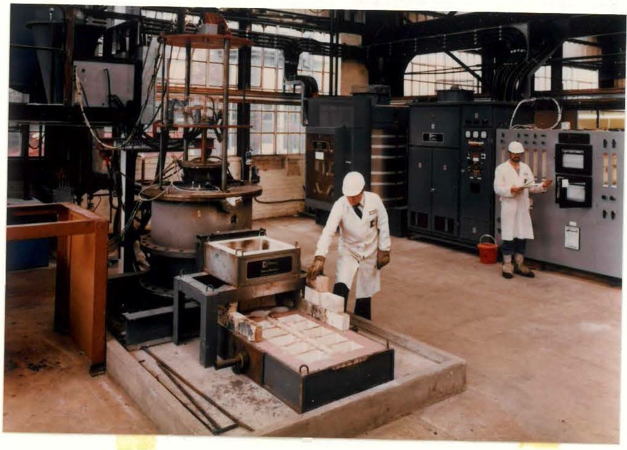

Figure 3.2 Davy McKee Plas11a Furnace Pilot Plant

088/945 16

**Davy McKee --.**

1. INTEGRATED ORE **PRETREATMENT AND PLASMA** SMELTING PROCESS
   1. **Process** Concept

The concept of the integrated process is shown diagramatically in Figure 5.1. Particulate feed ore and flux are fed into a Davy McKee multi-stage fluid-bed unit where pre-reduction and calcination takes place using reducing gas produced in the plasma furnace. Ore pre-reduction occurs using the chemical energy of the gas and the residual calorific value of the gas is used to preheat and calcine the feed. Mixed ore, flux and coal or coke are injected into the plasma furnace reaction sleeve, using, for instance, scrubbed recycle furnace product gas. Smelting takes place both in the reaction sleeve and the furnace hearth. The gas produced using coke in smelting iron ore in the plasma furnace has

been found to contain CO/H2/co2 in ratios between 8/1/1 to 10/1/1

at temperatures between 14001C and 16001C. More gas is produced

when coal is used as reductant and the CO/H2 ratio of the gas will be similar to that in the coal feed. Gas with these compositions

and temperatures can be used to pre-reduce, preheat and calcine iron ores.

Fluid-bed preheating, calcination and pre-reduction leads to good contact between gas and ore and both heat transfer and reaction are fast in finely divided materials. Fluid-bed equipment is therefore efficient, compact and low cost. The combination of fluid-bed pretreatment of particulate feeds with plasma smelting in the Davy McKee type plasma reactor eliminates the need for ore agglomeration and the preparation of metallurgical coke from oal. The capital and operating costs of the whole process using particulate ores may therefore be significantly reduced over other processes. The size of the cost savings will vary with ore type, plant location and scale of operation.

Finely divided ores are produced in a large number of

beneficiation processes when the ore is milled prior to producing

088/945 22

**7,**

Ii

�

**J**

**JI**

.,

61

I

71

ll J J'

#### I

ijj

#### I

**1**

]

.7_



**Davy McKee-----------------**

the concentrate. In addition, ore fines are produced from many ores during mining and handling. Particulate ores therefore represent a large proportion of ores currently treated and the integrated process has a wide range of applications.

088/945 23

r

I

I

###### J

D

ul

·

ol

I

JI

I

###### J

J J J J J J J J J J

�

□

J

**Davy McKee ,**

* **finis**

**W:zst\** --- **Gas flow**

,.**f---,L{}towc**-**r**6**St**•**ock**- **Solids flow**

I **_J**

**_......;:a.. .., MIii**

**MUied ore**

**Milladcn** 1

I--•

7 ScNbbcr

I

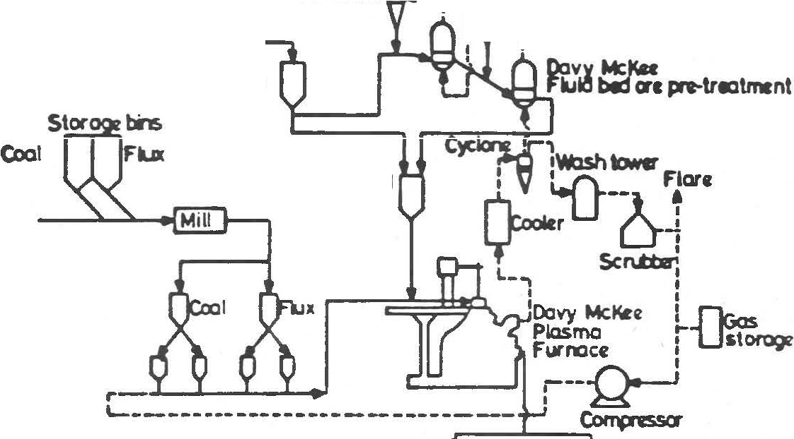

**Prc•treolld**

**ore**

**Sbg Metal**

Figure 5.1 Integrated Pretreatment and Plasma Smelting Process

088/945 24



]!

'

�

-1

l J

]

�

J

J

J

D

�

D

J

###### J

**Davy McKee --.**

* 1. **Status of the Integrated Process Technology**

The status of the development of the Integrated Process Technology is sullJilarised as follows:-

1. Fluid-bed ore reduction has been demonstrated as a collJilercial operation in the FIOR plant in Venezuela producing 320,000 tonne per annum of reduced iron briquettes (sponge iron) from iron ore and hydrogen rich gas.
2. Davy McKee Research and Oevlopment have extended the Company1s knowhow to the use of carbon monoxide rich gas in Fluid-Bed Ore Reduction Process. The technology is particularly appropriate for ore pre-reduction in the Integrated Process.
3. Davy McKee have developed extensive knowhow in the design and operation of the Hi-plas smelting furnace. The company is now prepared to design plasma furnaces based on the developed design for operation up to 10 MW. Davy McKee have a world wide sole licence to exploit the technology.
4. Following engineering design studies on the Integrated Fluid­ bed Ore Reduction and Plasma Furnace Technologies, Davy McKee is now prepared to design and construct an Integrated Process pilot plant to demonstrate the technology for the production of iron and ferro alloys.

088/945 25

I I

l

'I

n

j

7

J

l J 0

0

�

J J J

**Davy McKee ,**

1. **DAVY K:KEE TECHNOLOGY FOR METALS RECOVERY FR<l4 ELECTRIC ARC FURNACE (EAF) DUST**
   1. **Introduction**

Electric Arc Furnace (EAF) dusts have been classified as a hazardous waste in view of their lead, cadmium and chromium content and disposal is therefore strickly controlled.

A comprehensive study of the occurrance and treatment of EAF dusts has been prepared for the US Center for Metal Production (CMP) by Bethlehem Steel, and has been reported in a document entitled 11Electric Arc Furnace Dust - Disposal, Recycle and Recoveryt' Final Report, May 1985. The report identifies the widespread occurrence of these materials in the USA and the need for treatment technologies as a permanent alternative to disposal by land fill. One of the basic requirements of such processes will be the production of disposable products which meet EPA specifications.

A further desirable feature will be the recovery of the high value metal content of the dusts, eg zinc, chrome, nickel etc. Plasma furnace smelting and subsequent recovery of volatile metals was identified by the CMP study as a process route which meets all these needs. Davy McKee has extensive expertise in both these process technologies, based partly on in-house developments and partly on knowhow in proven processes.

A pilot plant programme in the Davy **McKee** plasma furnace facility together with a parallel engineering design and cost studies have been carried out aimed at metals recoveries from 5 000 to 20,000 tpa of stainless steel, plant dust arisings.

* 1. SuD111ary of the Davy McKee Hi-plas Process (Figure 6.1)

The Davy McKee technology comprises the following process steps:-

088/945 26

']

]

I

J I

J J' D I

□1

-, I

_j I

71

I

J 7 J

Q

]

]

j

0

0

�

J

**Davy McKee ,**

1. A simple feed agglomeration process which significantly improves dust transport and storage properties and minimises dust carry-over from the process.
2. A plasma smelting process in which the agglomeration feed is fed to the plasma furnace and the metal oxide content of the dusts is smelted. This process step is carried out in a Dav Mckee Hi-plas furnace which is designed to treat fine feeds. Non-volatile metals will be recovered in the furnace hearth while the volatile metals, such as zinc, **will** be recovered from the furnace gas in the third stage of the process.
3. Zinc recovery from the furnace gas by either,
   1. furnace gas quenching and zinc recovery in a lead **splas**

condenser. (Figure 6.1 **(a))**

* 1. furnace gas treatment to recover zinc oxide in a bag house or wet scrubber. (Figure 6.1. (b))

The selection of zinc recovery process will depend on the zinc content of the dust and hence the value in the product.

The technology has considerable advantages over alternative dust disposal and treatment routes.

Specific features of the Davy McKee process are:-

1. The process is economically attractive with a capital cost pay-back within an acceptable time.
2. The process steps have been separately demonstrated.

D88/945 27





**Davy McKee --.**

1. Valuable products ar recovered in the fonn of metal from the plasma furnace and saleable zinc or zinc oxide from the furnace gas treatment plant.
2. The fine dusts arising can be fed to the Davy McKee Hi•plas furnace with minimum prior pretreatment.
3. Coke breeze or coal may be used as reductant.
4. A slag will be produced which meets environmental specifications for disposal.
5. The process provides a permanent and profitable solution to arc furnace dust disposal.

088/945 28

d

I



�I

�

]

J

�

##### J

]

J

J

]

]

]

7

*---1*

**Davy McKee ,**

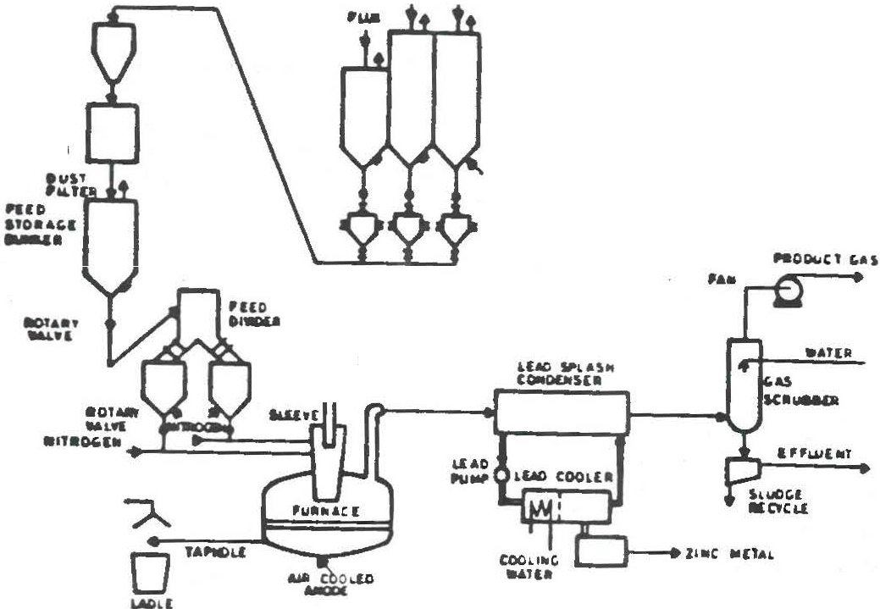**COAi. OUIT u,a,**

**11111,iuu**

**•uo**

**H:ErtCllllltYlQII**

**IUHUI**

**&l&&TC>•**

_,, .. , **MUU**

**•t1r.. 110•N•1**

**UT..:>CII**

HCD

"°""''

(a)

**a>Ne,,&Tl)IICMMKJI**

A

0

**&Ml**

... C.(X).£0

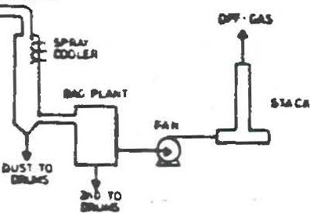**MOO(**

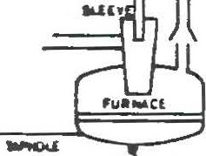

(b)

Figure 6.1 Metals Recovery fro11 Arc Furnace Dust

1. Recovery of Zinc Metal from High Zinc Dust
2. Recovery of Zinc Oxide from Low Zinc Dust

D88/945 29

**!11**

**J** 1

1

0 ::

J:

□

□ 11

.,

DI

**n**

,

I

o.

[1

I

17 I

......

�I

[1

Q

**0**

J

D

**u**

**0**

�

�

**Davy McKee --.**

1. APPLICATION Of HI-Pl.AS TECHNOLOGY TO METALS RECOVERY fR()I

FERRO-ALLOY **CONTAINING** SLAGS

Slags produced in ferro-alloy processes often contain relatively high concentrations of the ferro-alloy metal as well as other valuable steel plant metals. Similar slags are produced by refining iron containing vanadium, titanium etc. These slags are a valuable source of the metals and may be used to produce high value alloy products.

The metals as ferro-alloys may be recovered from slags by a number of routes including:-

1. Hydrometallurgical routes involving eg salt roasting, leaching and precipitation. This route is suitable for producing relatively pure high value products.
2. Carbothennic reduction of the metal containing slag using coke or coal to produce a high carbon ferro-alloy.
3. Production of higher value, low carbon ferro-alloy by silico thennic reduction in a double reduction step. The plasma furnace with a water cooled, non consumable electrode is particularly suitable for producing a low carbon product of this type.

The reduction processes (b} and (c) will also recover the other metal values directly from the slags.

Davy McKee have carried out programmes in the Hi-plas furnace pilot plant together with engineering design studies of ferromanganese production from manganese containing slags using both the smelting routes (b) and (c) above. The knowhow developed in equally applicable to other ferro-alloy materials.

D88/945 30

*]*

###### J

]1

##### 7

]I

]

□

],

1 I

]

J1

I

]

l

]

l

7

]

###### J J J

�

**DavyMcKee ­**

APPEN01x 1

HI-Pl.AS, DAVY t«:KEE HIGH INTENSITY PLASMA ARC SYSTEMS

(Hi-paas is the generic name for Davy McKee High Intensity

Plasma Arc Systems)

088/945

**r:**

LJ

D G [J

[ Q C

C

C

[

[

C

##### :L

1C

**LJ**

I[

**LJ**

C

1l]

I

f7

i

I **lJ**

I

I

I **ll**

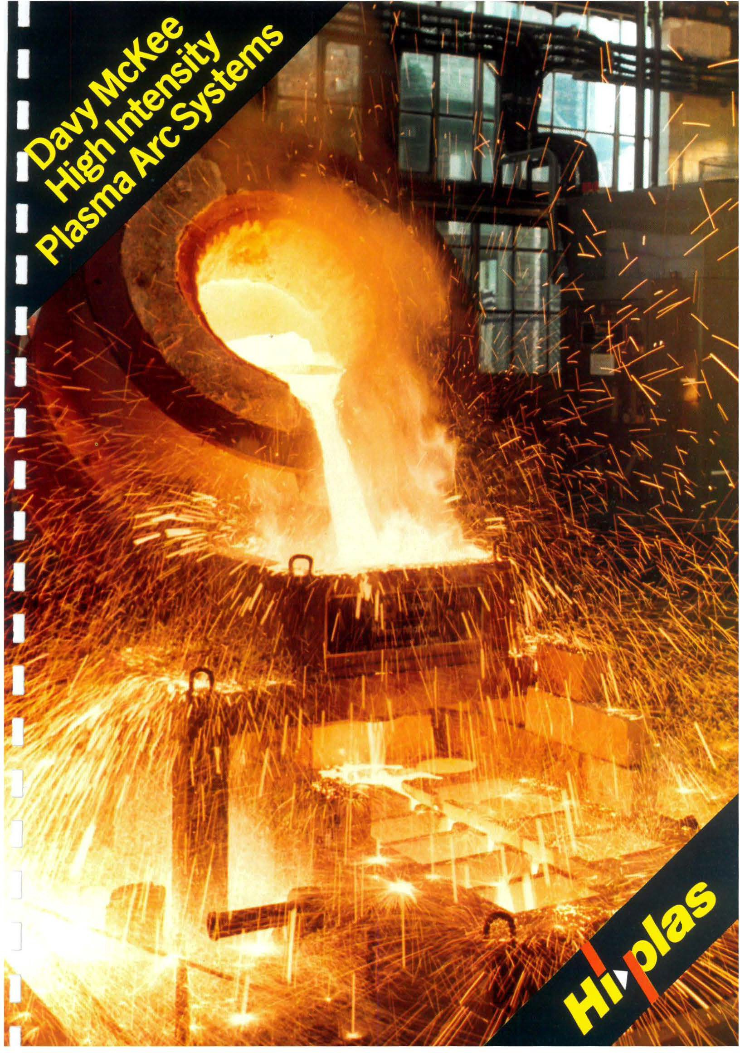

**The DavyMcKee advanced designof plasma reactor provides:**

Meltingand smelting capability

High efficiency heattransfer­ usingthepatented *sleeve* reactor

Direct feedingoforeandmetalfines­ without expensive materials preparation

Ability to treatsteelplant dustarisings

**DavyMcKee PlasmaFurnace**

**Lowcost metalproduction from ore finesisattainable through:**

:Cornb.inationof OM fluid bedand plasmafurnace technologies

Use offurnace off-gas fororepre-treatment

Replacement ofmetallurgical coke by coal/coke fines

**Integratedpre-treatment andplasma smeltingprocess formetalproduction fromorefines**

**Davy McKee plasma scrapmeltingprovides theadvantages of:**

Non-consumable electrodes­ eliminates expensive graphite

Improved alloy yields

Rapid scrap meltingusing

high power density plasma torch

Reduced environmental pollution­ virtually silent operation

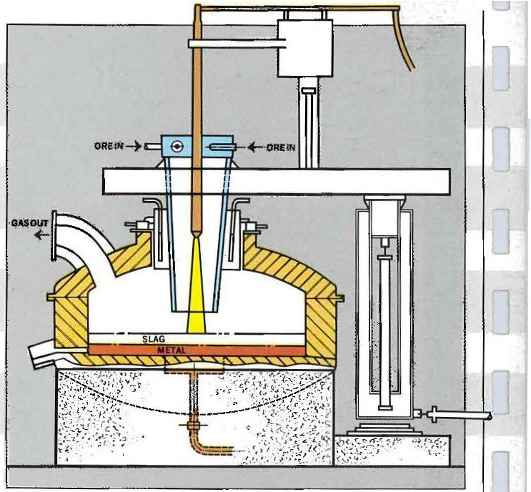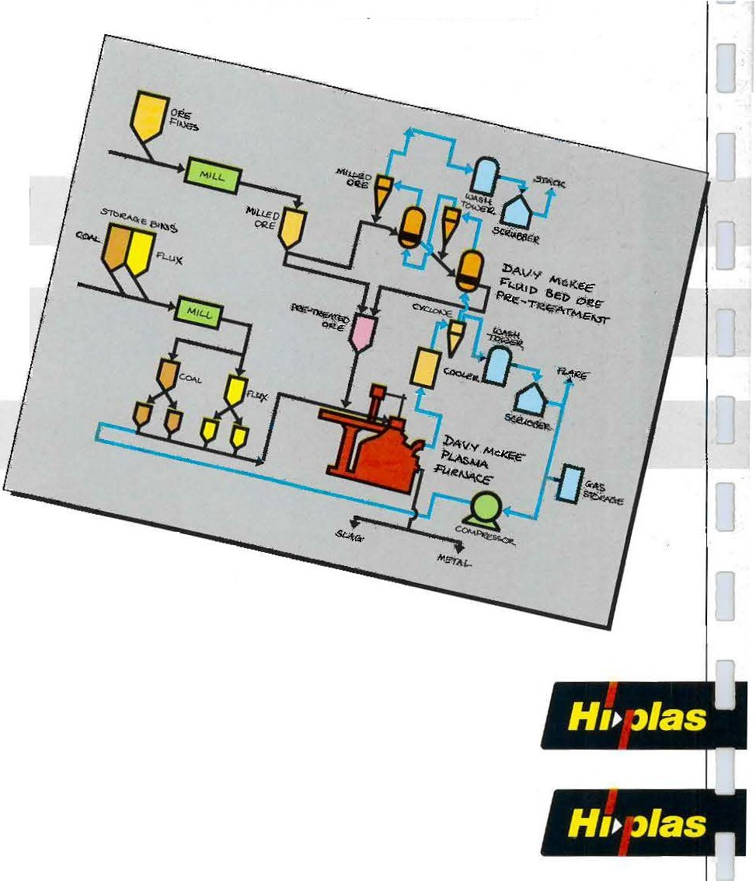

Voltage fluctuations eliminated- no expensive flicker compensation equipment required

**Davy McKee (Stockton) Ltd**

Ashmore House, Stockton-on-Tees, England, TS183RE Tel: (0642)602221Telex: 587151

***H1•Jlas***

**DavyMcKee ­**

APPENDIX 2

THEORETICAL BASIS OF THE DAVY MCKEE HI-PLAS FURNACE TECHNOLOGY

D88/945

**J**

]

J

]

]

J

]

]

**J**

�

**Davy McKee --.**

THEORETICAL BASIS OF THE DAVY MCKEE HI-PLAS FURNACE TECHNOLOGY

1.0 Arc Characteristics and Power Distribution in the Transferred Arc

The preliminary progranme was carried out using an argon arc together with argon carrier gas injected into the reaction sleeve, with and without iron ore, in order to investigate the distribution of heat radiated along the length of the plasma column. Some of the results are given in Figure 1.

Investigations up to 1500 A showed that arc voltage is relatively

insensitive to arc current but is strongly dependent on arc length. Voltage gradients are in the range 1.5 to 2.6 volts/cm and the intercept on the volts axis for zero arc length lies between 35 v and 56 v. The intercept voltage and corresponding power value are related to (i) the resistances in the external circuits, (ii) the voltage drop in the i1T111ediate vicinity of the cathode and anode and (iii) the resistance of the anode bath. The balance of the power is therefore associated with the arc column.

Further tests were carried out with zero feed addition using a cold furnace chamber to minimise the effect of heat radiation from the furnace. A low power arc was used (400 amps) and the arc voltage and power were measured as the arc length was increased by withdrawing the plasma gun up the reaction sleeve. The heat radiated within the sleeve was measured by the increase in temperature of the sleeve cooling water. The arc power calculated within the sleeve was almost completely accounted for by the power passing to the sleeve cooling water,thus indicating that the arc energy available may be calculated in the fonn of radiation. The results are sulllllarised in Figure 2. It is clearly seen that as the arc length increases the proportion of the power to the anode decreases whereas the proportion of the power radiated to the sleeve increases.

At a total arc length greater than 20 cm approximately 80% of the

arc power is radiated and as the arc length within the reaction

D88/945

l

**rl** I

�

rl

J

J

�]

]

�J

##### J

l

]

�

J

J

l

Q

**fl**

**_J**

**7**

I

I I

7

**.J**

**Davy McKee --.**

sleeve increases, the proportion of this power radiated within the sleeve increases.

088/945

**l**

]

I

J

**7**

**n**

I,..

**Davy McKee ,**

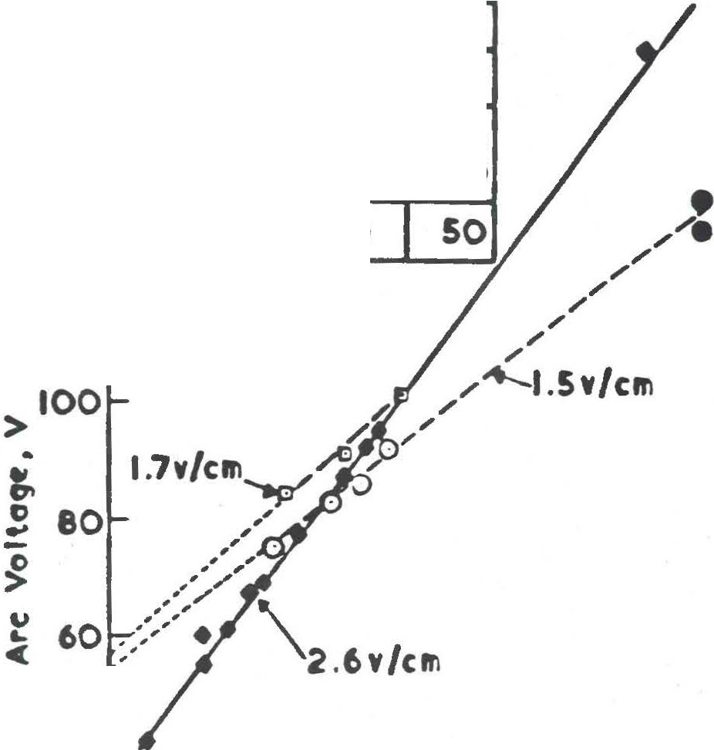



**180** ,----,----,�-,---........- �

•

**Ar.** I **P"'**

**Amps**

**Plaamo Feed**

...

160

**140**

120

**D 500** 100 0

0 500 **50**

* 100

**275** 100

* **275** 100

**40**, , 1r 1t

*I*

20 Bottom **Fttd**

of Slrrv« Porl1

0 10 20 30 40 so

0

Ate length, Cft'I.

Figure 1 Variation of Arc Voltage with Arc Length

088/893

l

7

l

*J*

1

##### J

7

1

##### J

]

l

J

�

##### J

'7

ri

;7

L

r

..

r



**Davy** McKee --.

Arc Length wlthln Sleeve, cm

lrY".,, 0 10 20 _30

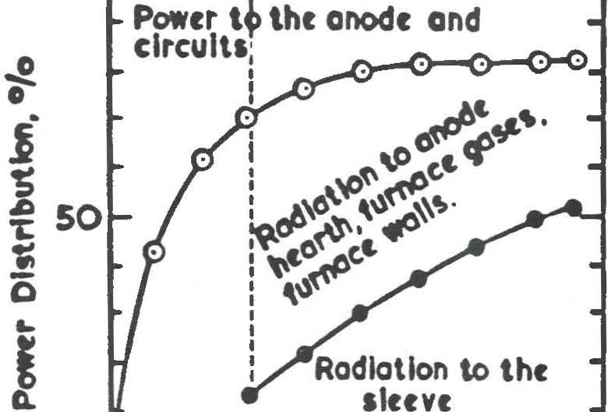

-0-

•

10 20 30 **40**

Total Arc ungth,cm.

Tola1 arc powtr-p0W(r to onod(• IOO

Total arc powtr Powtr to slrtvr

1 100

Total arc power

Figure 2 Power Distribution to Plasaa Arc Furnace without Feed Injection

088/893

|  |
| --- |
| J  J  u  J J J J J J J J J J J J  ] |
| ] |
| J  ] |

ru

**Davy McKee --.**

* 1. **Arc Power** Available for Iron Ore Melting on the Reaction Sleeve

The study was continued with feed injection tests. Ha11111ersley fine ore was used without flux or carbon additions to avoid the generation of gas product and to provide a melting system. It was possible to determine the power available for heating and melting the feed at selected cathode positions within the sleeve by deducting the sleeve cooling water power losses from the arc power within the sleeve, Figure 3. The power required to melt the feed (at 1 kg/min) and the position at which this would occur is indicated for cathode positions A and Band coincides within 1 cm of the position at which the film was seen to form. The consistency of these results provides further evidence that the arc energy is mainly transferred as radiation and that the proportion of arc power which is in the form of radiant energy increases with increasing arc length. It is concluded that the sleeve reactor is an ideal system for utilising the radiant energy of long arcs to heat the incoming feed. In the absence of the reaction sleeve the radiant heat is dissipated to the furnace refractories.

088/945

**_J**

|  |
| --- |
| 0  J |
| '] |
| J J J  Q |
| J J J J J  ] |

]

,.,.,

....I.

**r-,**

I

I..

l

-I

***r.***

I

I

IJ

**Davy McKee ,**

.,•

***M***

J.,

-**C**

IOOr

) **50**

**0**..,

l

**u**

**L**

**C**

**5 D IS 20**

Arc ltngth **within 11,nt, ctn.**

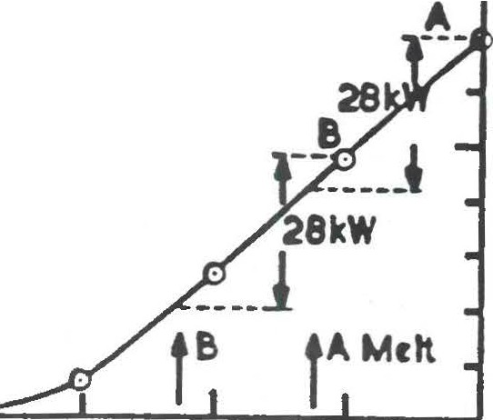

---, ,,--..--­

Film l8 *t*

Figure 3 Arc Power Available for Melting Iron Ore

088/893

J

I JI

]i

0

Q

0

0

J

7

l J J J J J 0

�

J J J r...

**Davy McKee ,**

1. Arc Characteristics in **a SElting System**

Arc voltage characteristics for an argon arc are compared for a series of tests with and without iron ore, coke and flux injection in Figure 4. The voltage gradient is low without feed but increases to about 10 v/cm during feed injection due to dust and product gas entrainment in the argon arc. The curves are drawn to intercept the voltage axis at 50 *v* which corresponds to the sum of the voltage drops as described above. The balance of the power is in the fonn of radiant arc power and may be as high as 90% for a 50 cm long arc. Sleeve reactor tip positions are indicated in Figure 4. and it is apparent that the reactor configuration is capable of utilising a significant proportion of the radiant power which is generated during extended arc operation.

088/945

�

□

J

*1*

l J

l J J J

l

]

l l

....

,.,

**Davy McKee --.**

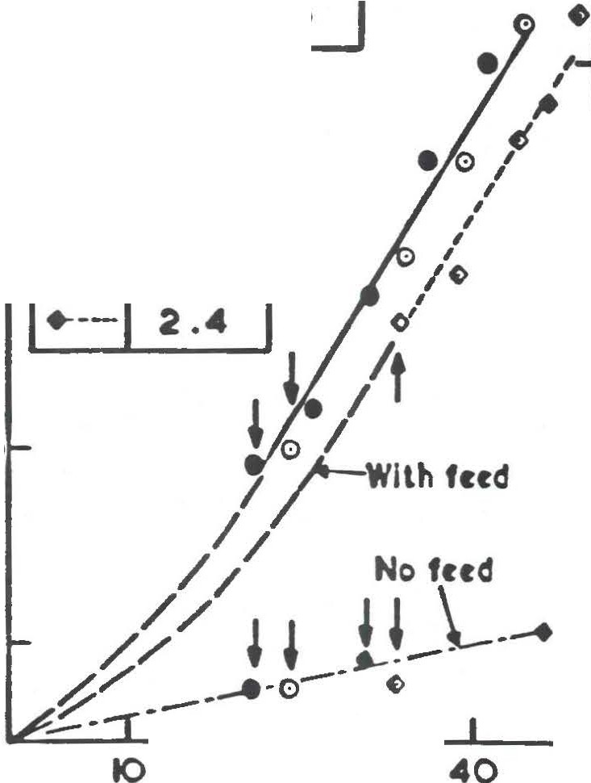

**alcrvr tip**

**Ferd kg** / •In.

* I **..C**

**300**

**200**

tOO

0

20

30

50

**2.0**

I **.6**

0--

'

>

..

.,

**0,**

**0**

**u**

**c**'-

Arc l�ngth, crn.

Figure 4 Arc Voltage Characteristics in Iron Ore Saelting

088/893

0

0

0

0

D J J

LJ

0

J

###### J

]

]

J J J

□

]

...

J

**Davy McKee --.**

1. **Power** Utilisation in **SElting** Reactions

The effectiveness of power utilisation in smelting (carbothennic reduction of oxide ore) reactions was examined using iron ore, coke and flux. This system was selected for the reactor study as the chemistry of the process is simple and well understood.

Details of the total power consumption expressed as sensible heat and reaction enthalphy, power losses to the furnace wall, sleeve cooling water and gun cooling water are given in the attached Figure 5. The arc power used was selected to provide the sensible heat and endothennic reaction requirements of the feed at the specific feed rate assuming complete reaction.

The furnace gas was analysed by GLC at intervals during the test and the product gas flow rate was determined using argon as a tracer since the selected plasma and feed gas flow rates were known. Product samples were retrieved at the end of each test and chemically analysed. The measurements were used as a basis for establishing the metallic yield and power consumption during smelting.

Power utilisation in the smelting reaction is illustrated in Figure 5 and is seen to be approximately 80% on this scale of operation. Sleeve and cathode cooling water losses are approximately 13% while losses to the furnace casing are 7%. Sleeve cooling losses in these tests are high as the reactor was unshielded and the contribution to the losses from furnace radiation was high. In the developed furnace design the reaction sleeve is shielded from the furnace radiation and losses will decrease. In addition when total power input is precise1y balanced by feed input, and therefore by power demand, the heat losses to the sleeve cooling water would be reduced. The resulting efficiency of utilisation of electrical energy will be 85% to 90%.

088/945



7

'7

**Davy McKee --.**

It has been demonstrated therefore that the utilisation of the whole plasma arc energy in the sleeve reactor leads to high efficiency of electrical energy use in the reaction.

088/945

•

**Davy** McKee --.

Arc Powtr 182kW

F�td rat, 2.4kg /min.

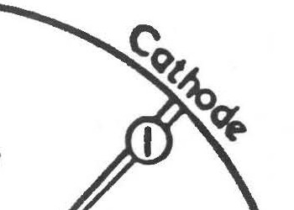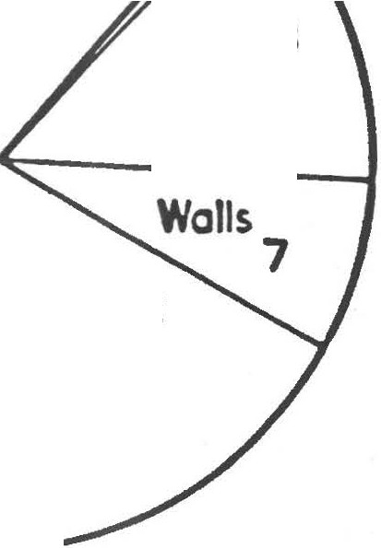

37

Reaction *tntrgy*

25°C

13

SlttVt

nsiblt hrot

of products, ISCX)OC

42

Plasma Furnoct Powtr Distribution

Figure 5 Power Utilisation in the l»4 Hi-plas Furnace In the Iron Ore Saelting

D88/893



n

b:

[

r

r

I

�

r

I

L

**Davy McKee --.**

**APPENDIX** 3

DAVY MCKEE STUDIES AND PUBLICATIONS **IN PLASMA** TECHNOLOGY

088/945



**Davy McKee ,**

**DAVY MCKEE STUDIES AND PUBLICATIONS IN Pl.ASMA TECHNOLOGY**

1.0 Internal Reports and Studies

"Plasma Arc Evaluation" by D Naden, 10.10.80.

A report for Davy McKee Management in which uses of plasma technology and potential business areas were identified, recorrmending technical development activities in specific topics.

* 1. "Technical and Economic Assessment of the Application of Ore Pre­ reduction and Plasma Smelting Technology to Iron and Ferro-Alloy Production" by D Naden, June 1983.
  2. "Investigation of the Reduction of Manganese Ore Feeds to Submerged Arc and Plasma Arc Furnaces using Furnace Gases" by O Naden and K Parkin, March 1983.
  3. "Development of Davy McKee Plasma Smelting Furnace" by P Kershaw, March 1984.

Detailed report of the plasma furnace development progrannne and investigation of the application of the technology to iron and ferro alloys ore smelting over the period 1981 to 1984.

* 1. "Reduction of Hanunersley Iron Ore using Gas Mixtures Containing Carbon Monoxide and Hydrogen11 by D Naden, G Wightman and K Parkin.

A report prepared following an extensive in-house study of iron ore fines reduction as a pre-cursor to a range of subsequent smelting processes, including plasma smelting and iron bath smelting using coal/oxygen injection.

088/945



I

l

]

]

7

Q

D

**Davy McKee------------------**

* 1. Reports of Studies for Clients
  2. a) "Investigation of the Reduction of Manganese Ore Fines using Submerged Arc and Plasma Furnace Gases11 by D Naden, October 1983.
  3. b} "Davy McKee Integrated ore Pretreatment and Plasma Smelting Process for Ferro-Manganese Production from Manganese Ore Fines; Flowsheet and Mass and Energy Balance Study11 by

D Naden and P Kershaw, January 1984.

Prepared for a producer following a collaborative study on ferro­ manganese ore fines carried out in the Davy McKee plasma furnace pilot plant.

* 1. "Application of Davy McKee Plasma Smelting Technology to Metal Production from Steel Plant Dust Arisings" by D Naden and

P Kershaw, January 1984.

A study prepared for a potential client to treat kiln dusts.

* 1. "Direct Iron Smelting - A Pilot Study" September 1984

A report prepared by Davy McKee and Hydro Quebec on the subject of an integrated fluid-bed ore reduction and plasma smelting process

|  |  |  |
| --- | --- | --- |
|  | for | iron production from North East Quebec concentrates. |
| 2.4 | a) | "Ferro-manganese Metal Fines Remelting: Report of the Davy |
|  |  | McKee Plasma Furnace Test Programme" by D Naden and P Kershaw, June 1985 |
| 2.4 | b) | "Fe-Mn Metal Fines Remelting: Preliminary Design and Indicative Cost of a Davy McKee Plasma Furnace by D Naden, |
|  |  | June 1985. |

088/945

I

J

**Davy McKee ,**

* 1. c) "Operating parameters Associated with the Davy McKee DC Transferred Arc Plasma Furnace Proposed for Re-melting Fe-Mn Fines11 by D Naden, July 1985.

A series of reports and documents prepared for a ferro-manganese producer following a test programme in the DM pre-reduction test rig and the plasma furnace pilot plant and subsequent engineering design and cost studies.

* 1. a) "Calcination and Reduction of Manganese Ore Fines using Reducing Gases"

2.5 b) 11Plasma Smelting Test Programme Report: Production of High Carbon Ferromanganese Alloys from Pre-reduced Manganese Ore Fines11 by D Haden and P Kershaw

* 1. c) 11Plasma Smelting Test Progra11J11e Report: Production of Medium Carbon Ferromanganese from Pre-reduced Manganese Ore Fines11

A series of reports carried out for a client following a test programme carried out in the Davy McKee pre-reduction test rig and the plasma furnace pilot plant. The test progranrne was followed by a detailed design of an integrated ore reduction and plasma smelting process.

* 1. "Davy McKee Technology for Metals Recovery from Electric Arc Furnace Dusts11 by O Naden, December 1985.

A document prepared for presentation to the North American Steel Industry in preparation for the construction of a dust treatment demonstration plant. This project is proceeding.

* 1. "Integration of Fluid Bed Reduction and Direct Smelting Technologies11, February 1986.

088/945

n1

# n

'

1!

n,

I

�

D

### r

�

l•

l J J

□

J

u

1l

0

D

**Davy McKee --.**

A study prepared by Davy McKee for an iron producer based on testwork by Davy McKee R&O and flowsheet studies, including mass and energy balances, by Davy McKee Stockton Ltd.

* 1. 11Study on the Manufacture of Silicon Products from Silica using Plasma Furnace Techno1ogy11 by D Naden and G Wightman, March 1986.

A study prepared for a potential client.

* 1. 11Production of Metallic Tin by a Two-Stage Process using Plasma Arc Furnace Technology" by P Kershaw, June 1986.

A study prepared for a potential client for tin production from a low grade concentrate.

* 1. 11Production of Low Carbon Ferromanganese from Manganese Slags using the Davy McKee Hi-plas Furnace".

A report currently being prepared following a paid study in the OMRO plasma furnace pilot plant.

* 1. A project related to phosphorus recovery for a phosphorus producer has recently been completed.
  2. "Electric Arc Furnace Dust Treatment by Plasma Smelting: Study of

Consumables Costs" by *D* Haden and P Kershaw, May 1986.

Prepared for a potential client as part of a bid for a technical study. The study indicated that the process economics were attractive.

* 1. Other Studies Carried Out for Clients
  2. Engineering design and cost study for an integrated fluid-bed reduction and Hi-plas smelting process for ferromanganese alloy production from ore fines.

D88/945

□

I



i

7. I

i]

|  |
| --- |
| 7  7  7  ] |
| J  **J**  ] |
| **J J**  ] |
| **J** |

**Davy McKee --.**

* 1. Engineering design and cost study for a Hi-plas furnace for ferrornanganese metal fines melting. This is expected to result in a colll!lercial 5 MW plasma furnace.
  2. Detailed engineering design and cost study of a plant incorporating a 7.5 MW Hi-plas furnace for recovery of metal values from 20,000 tpa stainless steel plant dust arisings. The plant design was based on test work carried out in the Davy McKee plasma furnace pilot plant carried out for as part of a proposal by OM for a stainless steel plant.

A cost study of this process indicates that the pay back time for the plant could be less than three years, after which the net income from the plant could be up to $100 US/tonne of dust treated.

* 1. Papers Presented and Articles Published **by Davy Mckee** R&D on the Topic of Plasma and Related Technology
  2. 11The Davy McKee Plasma System" by P Kershaw, Institute of Electrical Engineers One Day Conference, Thennal Plasma Industrial Process, held at Teesside Polytechnic, Middlesbrough, Cleveland, England, 4th June 1985.
  3. "Davy McKee Development of Integrated Processes using Fluid-Bed Ore Reduction and Plasma Smelting Technology for Ferro•Alloys, Iron and Steel" by D Naden, The Institute of Engineers, Australia, Symposium on Plasma Technology, Perth, Eastern Australia, 13th June 1985.
  4. "The Development of Integrated Ore Pre-Reduction and de Transferred Arc Plasma Smelting Technology for Iron and Ferro­ Alloys Production11 by P Kershaw and O Naden, 7th International Symposium on Plasma Chemistry, Eindhoven, The Netherlands,

1st to 5th July 1985.

D88/945

I

JI

H

□,

11

�

1

�

]

7

,.._J

1

7

�I

7

7

]

###### J J J

-□

D

**Davy McKee --.**

* 1. **11Davy McKee** Development of Integrated Ore Pre-Reduction and de Transferred Arc Plasma Smelting Technology for Iron and Ferro­ Alloys Production" by D Naden, P Kershaw and K Parkin, Extraction Metallurgy '85, An International Conference organized by the IMM, London, 9th to 12th September 1985.
  2. 11Fluid-Bed Ore Reduction and Plasma Smelting Technology for Metal Production from Ore and Metal Fines and EAF Dusts111 by D Haden and P Kershaw, Fifth International Iron and Steel Congress, Washington DC, USA, April 6th to 9th 1986.
  3. 11Davy McKee Fluidised Bed Reduction and Hi-plas Smelting Technology for Metals Production from Ore Fines and 01.(sts11, by D Naden, Steel Times International, June 1986.
  4. 11A Plasma Route to Iron and Ferro-Alloys 11, by D Naden, P Kershaw and J Ravenscroft, Metal Bulletin Monthly, December 1987.
  5. "Fluid-Bed Ore Reduction for Direct Smelting Processes" by D Naden, G Wightman and HK Jaworski, 46th Ironmaking Conference, Pittsburgh, PA, 29 March to 1 April 1987.
  6. 11Metals Recovery from Arc Furnace Dust Arisings by Davy McKee Hi­ p1as Technology" by D Naden, P Kershaw and G Wightman. Paper for Pyrometallurgy '87, an International Conference organized by the It+1, London, 21 to 23 September 1987.
  7. 11A 5 MW Plasma Arc Furnace for Production of Ferro-alloys11 by JG Heggie, M Gill, P Kershaw and DJ Moss. Presented at the Australian Institute of Energy, High Energy Technology Seminar in Melbourne, Australia, 21 July 1988.

088/945

7

J

J

l

7 I

**Davy McKee ,**

APPENDIX **4**

D88/945

**j**

**l**

**l**



l

J

l

J

]

###### J

,-,

**J**

n

7

- 3.1 -

•A 5 MEGAWATT PLASMA ARC FURNACE FOR THE PRODUCTION OFFERRO ALLOys• BYJ.G.HEGGIE, M, GILL P, KERSHAW AND D,J, MOSS

DAVY McKEE WILL SHORTLY BE COMMISSIONING A 5 MW PLASMA ARC FURNACE IN AUSTRALIA FOR A NEW MELBOURNE COMPANY PLASMA-ARC LTD. TliE FACILITY IS BEING SET UP FOR THE PRODUCTION OF FERRO ALLOYS FROM ORE AND METAL ANES.

THE DAVY •HI-PLAS• FURNACE FEATURES A PROPRIETARY SLEEVE REACTOR WHICH SURROUNDS THE HIGH POWER PLASMA ARC AND THE CHARGE FEED MATERIALS ARE INTRODUCED INTO THE MOLTEN METAL POOL VIA THE HIGH TEMPERATURE REACTION ZONE. THE ENGINEERING FEATURES OF THE FURNACE ARE DESCRIBED.

**PLASMA FURNACE TECHNOLOGY**

Plasma Furnace Design Principles

Open bath AC electric arc melting and smelting furnaces operate using short arcs at high currents and low voltages. Approximately 70% of the arc energy passes to the reactants in the furnace hearth, the remainder being radiated to the furnace. Plasma arc furnaces operate using longer arcs at higher voltages with a significant decrease in arc current As arc length increases however the percentage of arc **power** passing to the furnace hearth decreases, while the power radiated and convected to the furnace walls and roof increases. Measurements carried out by Davy McKee and others (t) (2) indicated that arcs 50 cm long can radiate over 50% of the energy to the furnace while the radiation from a 1 metre long arc can be up to 90%. If not used in the furnace reactions this represents an energy loss and will result in damage to the furnace walls and roof. The successful operation of a plasma arc fumace therefore requires a new approach to furnace design.

Davy McKee plasma smelting technology is based on the plasma furnace design principles developed by Gauvin and Kubanek (3) and on extensive pilot plant work carried out by Davy McKee in the Company's technical development facilities at Stockton on Tees, England. The plasma furnace design concept is now registered under the name Hi-Plas (High Intensity Plasma Arc Systems).

**L]**



**7**

J

7

J J

.J

J

**r1**

,-

* 3.2-

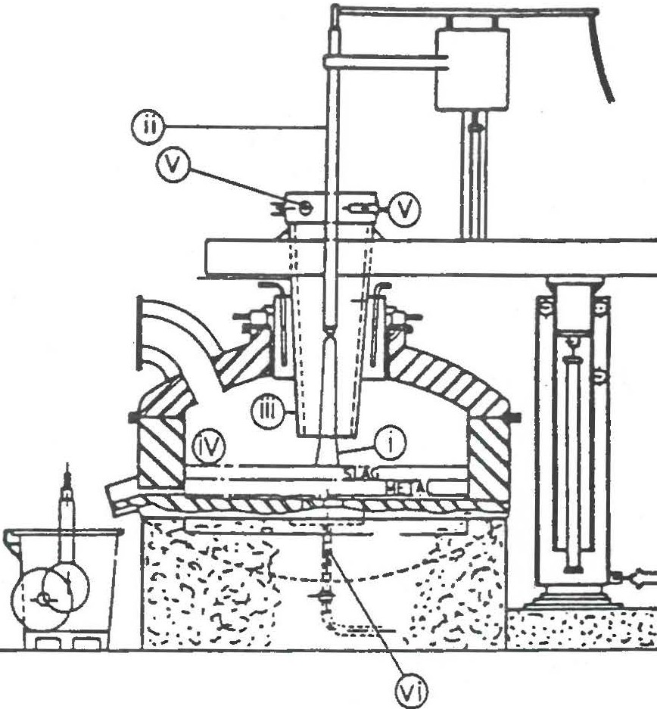

Figure 1 - Davy McKee Plasma Fumaea Design

An argon stabilised de transferred arc (i) is struck between the non�umable water cooled cathode gun Qij and the molten pool of reactants fiv) in the furnace hearth in contact with the anode in the bottom of the furnace (vtl. The plasma column passes down a water cooled r�action sleeve or cyclone reactor �ii) which surrounds a substantial length

of the arc column (i). Reactants are injected tangentially into the sleeve (iii) at a number of points M, above the plasma gun tip and with a sufficientty high velocity to **torm a** uniform coverir,g to the inner wall of the reaction sleeve. Radiant **and c:onvected** heat from

the arc melts the reactants to form a falling film of molten material flowing down **the inner** wall of the sleeve. The molten material then drops into the furnace hearth region **where the** reaction is completed in the motten bath heated by the impingement of the plasma arc. The continuous introduction of the reactants around the point of impingement of the *arc* prevents local overheating at the arc rool Full advantage is therefore taken in this design of all the heat in the plasma column which is used in the matting and smetting reactions. Rad'iation to the furnace walls and roof is minimised.

l

7

I

- I

j

I

I

l

7

--,

!

l



'7

(

l

###### J

D

* + 3.3 -

The operation of the plasma torch from a location which is remote from the hot furnace reactants ensures that the torch is not exposed to damage by splashing and hot fume. The resulting long arc is stabilised by the vortex action of the injection and reaction gases In **the sleeve** reactor. Arc instability caused by the turbulent **gases** in the smelting fumace Is therefore avoided.

Operation and Control

The furnace is designed so that the plasma torch can be readily raised and lowered on the vertical axis. On start-up the torch will be lowered to strike using a very short arc then raised into the operating position within the sleeve when feed is introduced.

Arc power is controlled by varying the current and arc voltage. During operation arc current will be constant for a fixed feed rate and hence power requirement, arc voltage however depends on arc length. Th� maximum length on the Plasma Arc Ud furnace is one metre above the surface of the bath, however longer arcs may be used in the Mure. As the metal and slag produced in the hearth raise the level in the bath the plasma torch can be raised and a constant arc length and hence voltage maintained.

The arc volts also depend on plasma gas composition. Using pure argon the voltage drop in the arc is approximately 2 v/cm, whereas when feed is introduced during the smelting process, dust and product gases (CO, CO2 and H2 etc.) are entrained into the plasma gas and the voltage can increase to 10 v/cm (1). A voltage of 7 v/cm has been used as the design basis for this furnace.

The arc power is increased by a similar ratio during smelting **as power** radiated is proportional to voltage drop in the arc. The power is therefore immediately available to the reactants in the sleeve reactor.

Furnace Refractories

The plasma smelting furnace designed for ferromanganese production will typically be lined with refractories as follows:-

1. Furnace base of 1600 grade low iron castable.
2. Fumace hearth anode construction using standard Davy McKee conducting hearth design surrounded by a chemically bonded magnesia castable.

J

I

•I

*]*

�1

(

##### 7

l 'I J 7

##### 7

1

]

*l*

7

�

j

##### 7

]

J

* 3.'4.

1. Magnesia chrome bricks are used for the furnace walls.
2. A silicon carbide ca.stable is used in the sleeve reactor with the remainder of the roof using the chemically bonded magnesia castable.

The Davy McKee plasma fumace pilot plant was operated intermittently for·over two years under a wide range of conditions before replacement of the hearth anode and wall refractories was necessary. Experience in conventional AC melting fumaces indicates that with no water cooling a reasonable minimum of 200 heats can be achieved for both wall and roof refractories before refurbishing is required. Roof and wall refractories life will however depend on the amount of radiation to which both are subjected from the bath surface and the plasma arc. When the plasma furnace is operated using the sleeve reactor described above, radiation from the arc will be less than in open arc systems. Roof and waJI refractories will therefore suffer less damage from this source. Refractory life at least as long as experienced in operating melting fumaces can therefore be expected in the Davy McKee Hi-Plas furnace.

Plasma Torch Design and Operation

The plasma torch uses a water cooled tungsten tip as the source of the DC transferred plasma arc and is similar in this respect to other operating plasma torch systems. The tungsten tip has a finite life and the frequency of replacement is, in Davy McKee's experience, dependent on torch current and the efficiency of cooling. Although operating experience in East Germany indicates that tip replacement will be required approximately *every* 200 hours, i.e. 9 to 1o days, operation with the Davy McKee pilot plant torch at currents up to 2000 amps has indicated that a significant longer life may be possible at the 5 to 8 MW level.

Argon consumptions in operating plasma melting furnaces have been quoted as 15 Nm3/h for a 10 MW furnace and 30 Nm3/h for a 20 MW furnace **(4).** Davy McKee plasma smelting furnace pilot plant experience operating at 0.35 MVA indicated a design basis of 12 Nm3/h for the 5 MW furnace.

Furnace Tapping

The SMW furnace is fitted with a Davy McKee taphole drill and claygun which can service 2 submerged tapholes to provide the flexibility required to process a variety of products on a campaign by campaign basis.





r'

j

1

l

n

;

'7

I



* 3.5 -

PEYELOPMENT Of THE PLASMA FURNACE TECHNOLOGY

Daw McKee Plasma furnace Pilot Plant

A plasma furnace pilot plant was designed and installed by Davy McKee in the company's Research and Development facility in Stockton on **Tees,** England. The fa�ility has been operating since 1982.

Work commenced on the 5 MW fumace in May 1987 with the manufacturing stage commencing in September 1987 following a four month basic engineering phase.

The furnace comprises the following equipment:•

1. The refractory lined furnace body with a nominal capacity of 1.2 m3 (approximately 6 tonnes of iron) together with retum path (anode) electrical contact system, and contact connections.
2. Both the roof and sleeve reactor are of water cooled membrane construction and refractory lined incorporating feed entry system and the plasma gun (cathode) entry port.
3. The plasma gun is a non consumable electrode incorporating **a** thoriated tungsten tip which is water cooled. Surrounding the inner cathode is the water cooled nozzle section which acts as a shroud for the plasma gas directing it over the tip.
4. The furnace backstructure assembly consisting of plasma gun raising and lowering system, roof and sleeve reactor raising and lowering system and backstructure slewing which are hydraulically operated.
5. The pneumatic injection equipment capable of continuously feeding four injection lines in the furnace sleeve.
6. The furnace gas cleaning system incorporating combustion chamber, gas cooling system and baghouse.
7. The power supply equipment includes rectification, transformer, DC series reactor and a high frequency spark generator. The system can supply a power of up to 5 MW in the range 50CX) to 7200 amps and 700 to 1000 volts.

:_j

Ji

- I

7 I

I

n!

ni

71

7

### n

�

J J

"l

�

0

J 1 J

�

ri

I

l

La

nl.

* 3.6 •

Powec uunsauoo io tbe Pm McKee P,asmo furnoco

Power uUJ1sation In carbothennic smelting ructions was examined In an extensive programme of investigation of the furnace operating parameters earned out in the Davy McKee plasma furnace pilot ptant (1) with a feed consisting of iron ore, coke -and tux.

Details of the totsJ power consumption expressed **as sensib&e heat and** reaction emhalphy,

power losses ta the fumaCe waJI, sleeve cooling **water and** cooOng **water are given** in

**1he attached** Figure 2.

Power utilisation in the smelting reaction is seen to be approximately 80'% at the pilot plant scale of operation. Cathode cooling water losses are minimaJ while losses tc the furnace casing are 7%. Sleeve cooling losses of 13% include a significant contribution from furnace radiation as in the pilot plant the sfeeve protrudes unprotected into the furnace. In **the** 5 MW furnace the reaction sleeve has a 70 mm thick retracto,y layer which is expected tc reduce the losses and therefore improve electrical energy utilisation.

ARC POWER 18 2 kW FEED RATE 2. 4 kg *I* min.

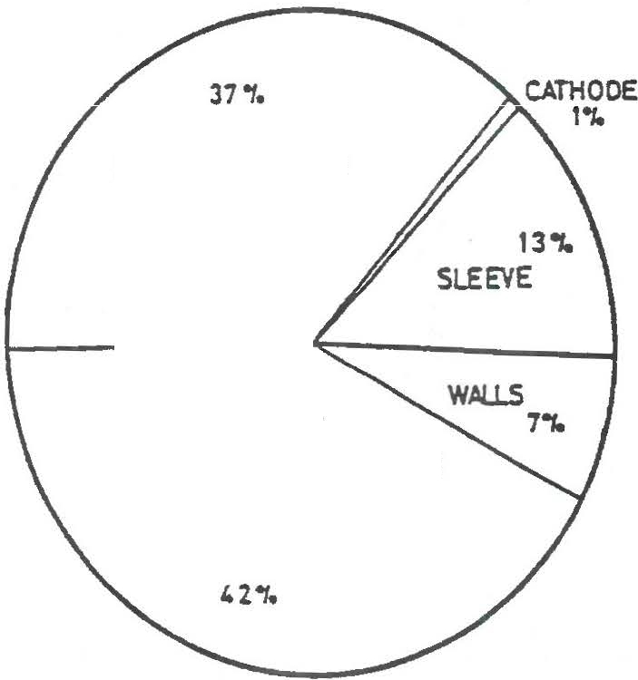

REACTION ENERGY

2s•c

SENSIBLE HEAT

*CF* PRODUCTS. t 5 oo•c

Figure 2 - Power Utilisation in the Davy McKee Hi-Plas Furnace Iron Ore Smelting



7

**l**

**7**

• 3.7 •

Condus;ons

1. The design principles of the Davy McKee plasma furnace have been proven in a pilot plant programme operated at a scale of 0.35 *t.KW.* The extensive programme has resulted In sufficient data being accumulated to design a 5 MW furnace for

Plasma Arc Ud which will shortly be commissioned In Melbourne, Australia.

1. The application of the Davy McKee plasma furnace to the treatment of metal fines has been co_nfirmed in tests in the plasma furnace pilot plant. Good mass accountability and high efficiency of electrical energy utilisation was achieved. Experience obtained on both ores and metal fines indicates that the technology will also be applicable to the treatment of a wide range of materials.

-

J

I I

n

u

7

1

I

-

0

71

##### J

D

C

l

�j

I

�I

I

n

�



* **3.8** -

**REFERENCES**

1. O Naden, P Kershaw and K Parkin •oavy McKee Development of Integrated Ore Pre-Reduction and de Transferred Arc Plasma Smelting Technology for Iron and Ferro Alloy Production·, p.335 to 353 in the collected papers of Extraction Metallurgy '85, Institution of Mining and Metallurgy QMM) Symposium, London, September 1985, published by IMM, 44 Portland **Ptace,** London Wl1 England.
2. Sven-Einar Stenkvist "Single Electrode de Arc Furnace· Iron and Steel Engineer,

May 1985, p 50 • 54.

1. W H Gauvin and G Kubanek, US Patent 4,466,823, April 1984.
2. **W.** Lugscheider, "Plasma Furnace Project for Economical Steel Production in Voest­

Alpine Group·, 7th ICVM Tokyo, November 1982.

J

7

***_1***

]

I,

I

J

-i**l** i

7:

JI�

n1



**'"'7**

**J**

**7** J

